The Nazis are well remembered for murdering well over 11 million people in the implementation of their slogan, *'The public good before the private good,'* the Chinese Communists for murdering 62 million people in the implementation of theirs, *'Serve the people,'* and the Soviet Communists for murdering more than 60 million people in the implementation of Karl Marx's slogan, *'from each according to his ability, to each according to his needs.*'  Anyone who defends any of these, or any variation of them, on the grounds of their 'good intentions' is an immoral (NOT 'amoral') enabler of the ACTUAL (not just the proverbial) road to hell." -- [Rick Gaber](http://FreedomKeys.com/selfishness.htm#utopians)

1. What do all of the people mentioned in the above quotation have in common?
   1. They all practiced collectivization of private property
   2. They all nationalized private industry
   3. They all outlawed private corporations
   4. They all believed they were doing the right thing
2. The author is critical of anyone who:
   1. Supports the idea that the collective good is more important the individual
   2. Shares resources with their fellow man
   3. Silently supports regimes that are responsible for killing millions
   4. Supports communism
3. A leader that would disagree with the author is:
   1. George W Bush
   2. Ronald Reagan
   3. Benito Mussolini
   4. Stephen Harper

"One byproduct of individualism is benevolence -- a general attitude of good will towards one's neighbors and fellow human beings. Benevolence is impossible in a society where people violate each others' rights." -- [Glenn Woiceshyn](http://www.capmag.com/article.asp?id=33)

1. How does the author see his role in society?
   1. The individual must take care of himself and his family
   2. The individual must obey the government
   3. The individual must help out his fellow man, if he can
   4. The individual should question the validity of rights of his neighbour

Three weeks after hijacked planes plowed into the World Trade Center and the Pentagon, a car bomb exploded outside the state legislature in Srinagar, Kashmir. The first attack, which killed thousands, was almost universally blamed on *terrorists*. The second attack, which left more than two dozen dead, was widely reported as a strike by *Muslim militants*.

Some people have asked whether we make any distinction between these terms

1. What could explain the understandings of the terms terrorist and militant in the above quote?
   1. The death toll
   2. The location on where the attacks occurred
   3. A difference in perspective
   4. A linguistic evolution over a short time period

“With governments, regardless of their political persuasion, increasingly impotent, unwilling, or unable to intervene on their citizens’ behalf, and seemingly having lost any sense of moral purpose, it is hardly surprising that the electorate is turning its back on conventional politics, even in countries that proclaim democracy as one of their greatest achievements.”

1. Which historical of the following could serve as evidence for the author’s argument?
   1. Recent Voter Apathy in Canada
   2. The Election of Adolf Hitler
   3. The liberal policies of FDR
   4. The popularity of Shock Jocks like Glenn Beck

Headline #1: **It Is Now Official - The US Is A Police State**

Headline#2: **Rule of Law is too important to Abandon**

Headline#3: **Goodbye, the truth has fallen and taken liberty with it**

Headline#4: **Detainees to be held without trial**

1. The above headlines raise concern about what type of practices found in liberal democracies?
   1. Torture
   2. Illiberal acts during an emergency
   3. Capital punishment
   4. Wire tapping
2. What government action are these headlines reporting?
   1. The War Measures Act
   2. The Emergency Act
   3. The Anti-terrorism Bill
   4. The Patriot Act
3. Which of the headlines offers us an unbiased attempt at reporting the news?
   1. Headline #1
   2. Headline#2
   3. Headline #3
   4. Headline #4

That leaves the government as the demander of last resort. In principle, every dollar spent by the government could cause national income to increase by more than a dollar if it leads to a more vibrant economy and stimulates spending by consumers and companies. By all reports, that is precisely the plan that the incoming Obama administration has in mind.

The fly in the ointment — or perhaps it is more an elephant — is the long-term fiscal picture. Increased government spending may be a good short-run fix, but it would add to the budget deficit. The baby boomers are now starting to retire and claim Social Security and [Medicare](http://topics.nytimes.com/top/news/health/diseasesconditionsandhealthtopics/medicare/index.html?inline=nyt-classifier) benefits. Any increase in the national debt will make fulfilling those unfunded promises harder in coming years.

1. The source is mainly cautioning us on :
   1. High Interest Rates
   2. The Baby Boomers retiring
   3. Government Spending
   4. The Obama Administration
2. Which historical figure would disagree with the source?
   1. John Maynard Keynes
   2. Ronald Reagan
   3. Milton Friedman
   4. Margaret Thatcher

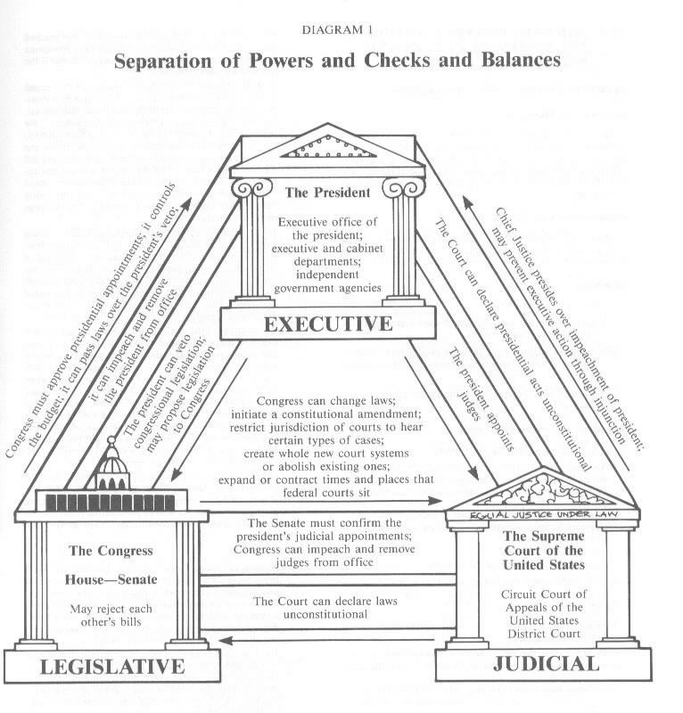

1. What concept is **most clearly** illustrated in this diagram?
   1. Checks and Balances
   2. Universal suffrage
   3. Tolerance of dissent
   4. Responsible Government
2. How does the system in the graphic differ from the Parliamentary system found in Canada?
   1. Canada does not have a Senate
   2. Canadian Judges are not separated from the legislative branch
   3. Canadian Prime Ministers are part of the Legislative and Executive Branches
   4. Canadian courts cannot declare laws unconstitutional

The bottom line to all this is that economic freedom leads to the most prosperity. Don't restrict labour and capital other than to prevent coercive harm to others. Don't tax labour or enterprise. Get public revenues from rent and pollution fees. Let the market handle the money and banking. True free trade and enterprise are good; decentralized and market-based governance works best. As Henry George said, economics and ethics are one. The environment and the economy are one. Good governance and economics are one. Share rent, charge for damage, and don’t steal wages.

1. Considering that this source was written in the 1980’s, what would we call an advocate for the economic strategies being prescribed here?
   1. Classical Liberal
   2. Modern Liberal
   3. Neo-conservative
   4. Neo-Socialist
2. Simplified, the main message of this source is that the government should:
   1. Raise taxes
   2. Intervene in the economy
   3. Allow for a free market
   4. Protect Investors

Source 1

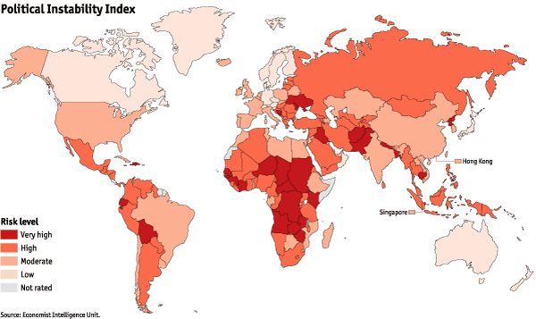

Source 2:

THE global economic crisis is already having a severe social impact in many countries, mainly by causing unemployment to rise quickly. The political impact may take longer to be felt: so far only two elected governments, in Iceland and Latvia, have been ousted after popular protests. More regime changes, possibly less peaceful ones, may follow as economic conditions worsen. A new report from the Economist Intelligence Unit, a sister company to *The Economist*, assesses the political vulnerability of countries by looking at indicators of underlying stability, together with economic distress. For the coming year or so 95 countries are judged to be at high risk of instability, compared with 35 in 2007. The most vulnerable states, such as Zimbabwe, suffer from a toxic combination of bad government and a free-falling economy.

16 After combining the information from both sources, we can conclude that:

1. Canada’s economy is strong but politically unstable
2. South America is a place to avoid
3. Economic instability can lead to political problems and vice versa
4. The future of the world looks bright

17. Based on what we know about the about the past, those regions with the highest instability are most at risk of:

1. Adopting an extremist leadership
2. Embracing Communism
3. Being attacked by a neighboring country
4. Disappearing from the map

**Where are the most people imprisoned?**

AMERICA leads the world in incarcerations, both in terms of the total number of people it puts inside and in the proportion of its citizens that end up behind bars. China lies comfortably ahead of Russia in third place, though a far smaller percentage of China's population ends up in the clink. Though India is in fifth place over all, just 33 people in every 100,000 are thrown in the slammer.

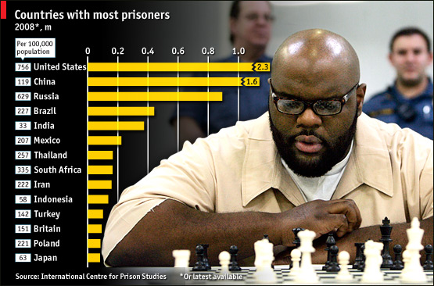

18. Why might these results come as a shock to many Americans as well as the International community?

A. It is often criticized for Human Rights abuses

B. It has higher rates than some authoritarian dictatorships

C. Russia has always had the highest rates

D. A democracy such as India ranks very high

19. How might an official in the US justice department defend the results of the study?

A. “Freedom cannot be achieved unless there is law and order in the country”

B. “Superpowers must put limits on dissent in order to survive”

C. “It is our national interest to be a worldwide leader in all things”

D. “China often misrepresents the facts in studies such as this”



20. Which of the following phrases matches the message of the political cartoon the best?

1. Cartoonists have nothing of value to contribute to society
2. Pluralist societies have difficulty respecting all their members, all the time
3. Commenting on Religion and Politics is irresponsible
4. Being a responsible journalist is an impossibility

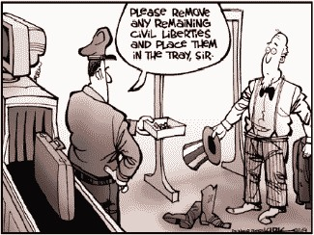

21. Which of the following values are in conflict according to the cartoon?

1. Collectivism vs. Security
2. Independence vs. Freedom
3. Freedom vs. Security
4. Liberty vs. Freedom

22. An opponent of the cartoonist would point out that:

A. The gentleman was searched in a dignified manner

B. Security sometimes demands a loss of personal freedom

C. Security sometimes demands and increase in personal freedom

D. Only those people of North American dissent are inconvenienced by increased security

**Speaker 1**

A responsible government does not spend any more on necessary government than it collects through a taxation system that maximizes economic growth, jobs, wages, family income and overall prosperity for working people. In Washington today, irresponsible leaders are putting our nation's future in jeopardy by borrowing trillions of dollars more than it can collect in taxes to pay for unnecessary government and in the process making changes to our taxation system that distort economic growth, kill jobs, and make our fiscal outlook even bleaker.

Our national debt is more than $12 trillion, having doubled in the past eight years. The Obama administration's 10-year budget forecast predicts the national debt will triple to $17.5 trillion by 2019. When Medicare and Social Security spending are included, the debt is closer to $65 trillion.

If these numbers do not improve in the next 15 years, the national debt will exceed 100 percent of gross domestic product (GDP), meaning the federal government will owe more than the entire value of the American economy. No nation can endure such reckless spending.

**Speaker 2**

The only reason the economy isn't in a double-dip recession already is because of three temporary boosts: the federal stimulus (of which 75 percent has been spent), near-zero interest rates (which can't continue much longer without igniting speculative bubbles), and replacements (consumers have had to replace worn-out cars and appliances, and businesses had to replace worn-down inventories). Oh, and, yes, all those Census workers (who will be out on their ears in a month or so).

But all these boosts will end soon. Then we're in the dip.

Retail sales are already down.

So what's the answer? In the short term, more stimulus -- especially extended unemployment benefits and aid to state and local governments that are whacking schools and social services because they can't run deficits.

But the deficit crazies in the Senate, who can't seem to differentiate between short-term stimulus (necessary) and long-term debt (bad) last week shot it down.

In the longer term, we need a new New Deal that will bolster America's floundering middle class. Expand the Earned Income Tax Credit and extend it up through the middle class. Finance that extension through higher marginal income taxes on the wealthy, who have never had it so good.

Questions:

23. What can be said about the writers of Source 1 and Source 2?

a. Speaker 1 is a Neo-Con and Speaker 2 is a Communist

b. Speaker 1 is a modern liberal and Speaker 2 is a classical liberal

c. Speaker 1 is a modern liberal and Speaker 2 is a Neo-Con

d. Speaker1 is a neo-Con and Speaker 2 is a modern liberal

24. Both Speakers would likely agree on

a. The need to create jobs to battle the recession

b. The need to increase taxation to pay off the debt

c. The need for stimulus spending to create jobs

d. The need for deficit financing to recover from the recession

25. An important point of disagreement between the two speakers is

a. Speaker 1 is talking about more long-term issues

b. Speaker 2 is talking about more long-term issues

c. Speaker 1 advocates more government intervention in the economy

d. Speaker 2 advocates less government intervention in the economy

26. Which of the following economists would have favoured Speaker 2’s approach?

a. David Ricardo

b. John Maynard Keynes

c. Adam Smith

d. Friedrich Heyak

e. Selma Hayak

27. Cabinet solidarity means

1. cabinet ministers are also elected members of parliament
2. cabinet ministers must publically support the initiatives of the government
3. new legislation must be reviewed by all cabinet ministers
4. government departments are responsible to the presiding cabinet minister

28. From the perspective of many socialists, health care services must be controlled by government in order to ensure….

1. medical professionals receive high wages for their services
2. citizens of all incomes receive equal access to medical services
3. the profit motive thrives and encourages advancements in medicine
4. health services are not burdened by people seeking treatment for minor ailments

29. Which of the following would be acceptable to a laissez faire capitalist?

1. raising corporate tax rates to fund higher social services spending
2. eliminating regulations that limit competition among passenger airlines
3. creating an automotive ‘Czar’ to oversee the automobile industry
4. nationalizing the mining industry to preserve jobs and thus taxes

30. Which of the following is typical of market oriented economies such as the USA?

1. a small portion of health care is privately owned
2. consumers face frequent shortages of necessary goods and services
3. many economic decisions are made through the principle of ‘invisible hand’
4. generous support is provided by the government for the disabled

Hyperinflation in Germany in the ‘20’s had a devastating effect on the lives of most Germans. But perhaps the most impact was felt upon the new democracy created after WWI. The timing of the crisis meant that economic despair and the new Weimar government became inextricably linked in the peoples’ minds. These disenchanted citizens were much more receptive to the voices of new political parties and ideas.

31. The information contained above suggests that economic hardship in

Germany fostered beliefs that were:

1. racist
2. socialist
3. extremist
4. ultra-nationalistic

32. The result of the situation described above was that

1. citizens overwhelmingly supported communist opinions and decision makers
2. citizens rejected democratic solutions and opted for fascism
3. citizens demanded a return of the monarchy which had been abdicated by Wilhelm II
4. citizens embraced democracy and new Keynesian reforms

The corporate scandals that have recently rocked the foundations of American society have revealed an ugly side of the ‘free market’. Greed gone Rampant. These scandals have provided evidence to critics that they now have evidence that the free market society is destined to collapse. Nothing is further from the truth.

Those who are quick to condemn the current crisis as evidence that a more activist and collectivist government is needed should ask themselves some important questions. How well did Russian society flourish under seven decades of Communist rule in the Soviet Union? What percentage of income do Canadians and Swedes pay to support government operations? Do governments ever mismanage taxpayers’ money? The answers to these questions make it clear that the best solution is not a knee-jerk reaction. We simply need to weed out the guilty and corrupt and get back to business as usual so that we can continue to reap the benefits of an economic system that even Karl Marx recognized as the most productive ever developed.

33. The author of the commentary argues the benefit of the free market is that it

1. allows for equitable distribution of wealth
2. eliminates boom and bust cycles
3. ensures an efficient use of resources
4. creates broad based prosperity

34. The writer dismisses other systems by implying they…

1. offer few services to the general public
2. serve only the needs of an elite group
3. are based on irrational philosophers of old
4. are ineffective in managing use of resources

35. The likely purpose behind this commentary is

1. to condemn the actions of corporate bosses
2. to restore investor confidence in the marketplace
3. to justify an increase in government spending
4. to encourage debate on possible reforms to the system

35. A socialist would likely concur with the writer on the idea that...

1. recent scandals are a result of ‘greed gone rampant’
2. the solution is to ‘get back to business as usual’
3. society has become corrupt and individualistic
4. taxation increases are the best possible solution

…in 1936 the head of the association of Nazi lawyers issued the following expectations for judges:

1. it is not the duty of a judge to impose a system of universal values or to enforce a law superior to the national community. His role is to safeguard the racial community, to eliminate dangerous elements , arbitrate disputes and prosecute harmful acts.
2. Nazi ideology as expressed by the Fuhrer, is the basis for interpreting the law
3. A judge has no right to scrutinize or criticize a decision by the Fuhrer. A judge is bound to enforce what the Fuhrer wants the people to do.

36. Which of the principles from the excerpt for expectations of judges in Nazi Germany is incompatible with those in democratic states?

1. to safeguard the racial community
2. to arbitrate disputes among citizens
3. to eliminate dangerous elements
4. to prosecute harmful acts

37. The above excerpt supports a generalization that in Nazi Germany there was an absence of

1. laws to ensure consistent application of Nazi beliefs
2. legal mechanisms to suppress dissidents and their ideas
3. judicial power to enforce the laws of the state and leader
4. judicial power to provide ‘checks’ on the power of the executive

….Aboriginal communities have characterized by a flat political structure that maximized the involvement of individuals…. Everyone including men , women and children had an opportunity to express an opinion on an issue. These expressions of opinion could occur during a family or clan meeting, at spiritual or cultural events, or even at full tribal councils. The result was often a decision that reflected the various interests expressed.

38. The decision making process being described above can best be labelled

A. direct democracy

B. republican democracy

C. parliamentary democracy

D. representative democracy



39. How would a supporter of the police justify their actions in the source above?

A. They would argue that law, order and stability must always be maintained.

B. Make us aware of the Canadian Charter of Rights and Freedoms

C. Use examples of past demonstrations and riots and how the police were brutalized in those instances.

D. Complain that the demonstrators were un patriotic

40. Based on what you know about protest groups, what event lead to this confrontation between police and citizens?

A. Ghandi’s civil disobedience movement

B. America’s involvement in Vietnam

C. Burma’s pro-democracy movement

D. The Orange Revolution