Test Taking Strategies

Strategy 1:
Cover the options while reading the stem of the question and try to answer the question
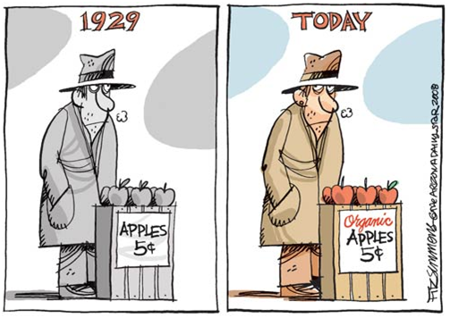

1. The main idea of the cartoon is that

2. According to a modern liberal, the conditions that caused both the Great Depression and today’s Great Recession could have been avoided by

3. A classical liberal would most likely support which of the following actions to improve the conditions depicted in the cartoon?

1. The main idea of the cartoon is that
A. The quality of apples and other produce has greatly improved since 1929
B. There is very little difference between the Great Depression of the 1930s and today’s Great Recession
C. The United States government was far more effective in dealing with the Depression of 1929 than today’s recession
D. Today’s recession was caused, for the most part, by problems created by the Great Depression

2. According to a modern liberal, the conditions that caused both the Great Depression and today’s Great Recession could have been avoided by
A. Greater government intervention and regulation of the economy
B. Relying on laissez-faire economic practices and policies
C. Increased taxation of the poor and the working class
D. Nationalizing all major industries

3. A classical liberal would most likely support which of the following actions to improve the conditions depicted in the cartoon?
A. Enforcing stricter limitations on the activities of entrepreneurs
B. Allow the market to correct itself without government intervention
C. Employing social programs and public works projects to stimulate the economy
D. Create government planning agencies to determine production of goods and setting prices

Strategy 2:

Treat option as True-False and choose the answer that is most true

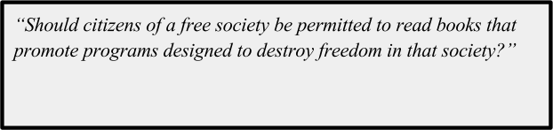

Faced with this dilemma, a person who values personal freedom over group security would be most supportive of a decision to

A. ban the books and allow no one to read them
B. permit the books to be read by all people without restrictions
C. allow the books to be read only after they have been edited to remove offending passages
D. permit the books to be read only by those who are most capable of understanding their message

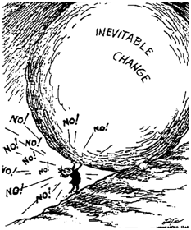

The individual represented in the cartoon could best be described as a

A. radical
B. reactionary
C. liberal
D. progressive

Strategy 3:

Read questions before reading sources-Read with a purpose

Source A
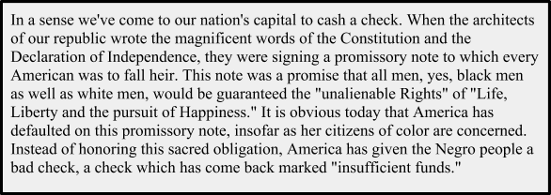

Source B

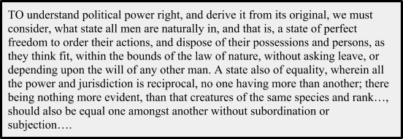

Source C
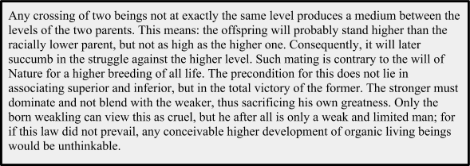

Source D
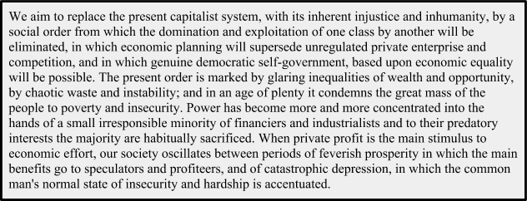

Which of the above sources mainly are concerned the “theme” of “Race.”
a) A& B
b) B & C
c) B & D
d) D & E

Which source is mainly concerned with the characteristic of “Human Nature?” and the characteristic of “Social Organization?”
a) A
b) B
c) C
d) D
Which source is concerned with the theme of “class?”
a) A
b) B
c) C
d) D

Strategy 4:

Highlight The Proof/Highlight Key Terms

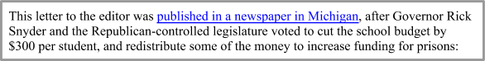

Dear Governor Snyder,
In these tough economic times, schools are hurting. And yes, everyone in Michigan is hurting right now financially, but why aren’t we protecting schools? Schools are the one place on Earth that people look to to “fix” what is wrong with society by educating our youth and preparing them to take on the issues that society has created.
One solution I believe we must do is take a look at our corrections system in Michigan. We rank nationally at the top in the number of people we incarcerate. We also spend the most money per prisoner annually than any other state in the union. Now, I like to be at the top of lists, but this is one ranking that I don’t believe Michigan wants to be on top of.
Consider the life of a Michigan prisoner. They get three square meals a day. Access to free health care. Internet. Cable television. Access to a library. A weight room. Computer lab. They can earn a degree. A roof over their heads. Clothing. Everything we just listed we DO NOT provide to our school children.
This is why I’m proposing to make my school a prison. The State of Michigan spends annually somewhere between $30,000 and $40,000 per prisoner, yet we are struggling to provide schools with $7,000 per student. I guess we need to treat our students like they are prisoners, with equal funding. Please give my students three meals a day. Please give my children access to free health care. Please provide my school district Internet access and computers. Please put books in my library. Please give my students a weight room so we can be big and strong. We provide all of these things to prisoners because they have constitutional rights. What about the rights of youth, our future?!
Please provide for my students in my school district the same way we provide for a prisoner. It’s the least we can do to prepare our students for the future…by giving our schools the resources necessary to keep our students OUT of prison.
Respectfully submitted,
Nathan Bootz
Superintendent
Ithaca Public Schools

1. Which principal of liberalism is Nathan Bootz criticizing in this letter?
A. Rule of Law
B. Individual Rights and Freedoms
C. Private Property
D. Competition

2. All of these principals of collectivism are referenced in this letter except?
A. Collective Responsibility
B. Adherence to Collective Norms
C. Economic Equality
D. Collective Interest

