Film Study

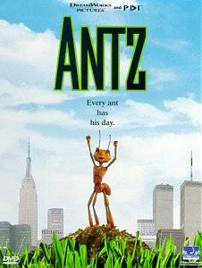

**Key Concepts:** Ideologies: Collectivism, Individualism, Liberalism

**Task:** In the film Antz, the main character Z-1495, or Z for short, desires change. Unfortunately, he is faced with the challenge of being an independent thinker in a collectivist society. Consider what you have learned in class regarding ideology to respond to the questions in the context of the film. Be prepared to explain your responses in class discussion.

1) What are some of the things that Z desires to change in his life?

2) Provide two examples of individualism and two examples of collectivism from the film.

What a bunch of losers. Mindless zombies capitulating to an oppressive system.

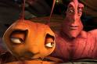

3) When born, do individual Ants have a choice in life to do what they desire? Explain your response.

4) What happened once the workers got word of Z’s independent thought?

5) What does Insectopia signify to Z? What do you believe Insectopia represents in terms of political theory?

6) General Mandable was giving orders to find Z and kill him. His response to the soldiers query, “Now you see how dangerous individualism can be; it makes us vulnerable.” What message is being reinforced by the general?

7) How does the film Antz demonstrate the problems or obstacles of individualism in a collectivist society?

8) Traditionally, liberalism has embraced freedom of thought as well as the concept of change. Provide two examples from the film of what may have been “liberal” ideas in the colony.

Why does everyone have to dance the same?

