Nazi Germany Document Assignment
Document A

Background: The Nazis set about establishing their own rituals and holidays immediately after taking power. This interesting article from the party journal for such matters discusses what to do with existing holidays and rituals, most of which had a Christian basis.
It is thus necessary to give inherited customs a meaning that reaches each member of the community in the same way (that is, a political meaning that reaches the people as a whole).
"Christmas" is an example, as we will see.
When we conduct such a holiday or ceremony, we want — as in everything else — to mobilize the spiritual or emotional strengths of the community for National Socialism. For example, Christmas is an inherited holiday about a theoretical peace for all of humanity. There is no national or social necessity to believe in this. However, we can present it as a holiday of actual domestic national peace, which is in fact without question a critical demand of the National Socialist people's community, to each individual German. If we make visible the blessings of this actual peace, along with its foundations and requirements, then "Christmas" doubtless can be a high point in the course of the political year. Both according to popular custom and popular view, the Christmas holiday can justifiably be seen as a festival of the nation.
From this perspective, it fits clearly in the political and worldview arena.

Document B

Background: Eugen Hadamovsky was a leading Nazi radio expert, and the author of a half dozen books with heavy propaganda content. His title was Reichssendeleiter, or national programming director. Here, he discusses the effective use of radio for political purposes.

Decisive political events do not take place “behind the scenes,” but rather they are intended to gain the participation of the whole population. Dr. Goebbels opens the doors, the conference rooms, the meeting halls, the four walls of diplomatic negotiations, and lets the people and the world participate. The broadest public participates in important events through pictures, news reports, the accounts of capable announcers, or through direct broadcasts of political events.

This May, as the German-Italian Friendship and Mutual Support Pact was signed in the Embassy Hall of the Reich Chancellery, we found ourselves there with the Führer, the foreign ministers of both countries, the commanders of the German army, and many German and Italian diplomats.

The announcer chosen by the Central Programming Office (Landgraf from Berlin) understood how to convey this truly historic hour with almost military objectivity, avoiding empty phrases and emotion. It was one of the most interesting and gripping broadcasts of the year.

Another example. On 1 May, the Führer received the workers, Hitler Youth, and BDM members who were victors in the Reich Occupational Competition. He spoke a long while with them, shaking each individual's hand, asking about their lives and their jobs. He discussed inventions, agricultural and industrial work, German production, family and household matters. We could listen to the Führer in a way we otherwise cannot.

An hour or two later, we chose several scenes from the event and our announcer used them to provide a lively account that once again was one of the most effective broadcasts. It was one of the programs that draws listeners to us! There are probably hundreds of thousands interested in music or literature, in symphonies or plays. But the millions who make up the audience of the new National Socialist radio are interested in politics. They are attracted by political radio. They are more interested in participating in great political events than in listening to a play by Mr. Fritz Müller or a serenade by Heinz Schulz. For them, the most important thing on the radio is the Führer’s voice.

Document C

Background: This is Max Amann's speech at the 1936 Nuremberg Rally, taken from the official party proceedings. Amann was one of Hitler's oldest friends, and controlled the Nazi Party's publishing system.

A look back before our seizure of power reminds us how numerous the problems of the press once were. Our few newspapers with their limited circulations fought heroically in the front lines to gain power. They stood against several thousands newspapers that represented other ideas and interests. There were many differences between the leading newspapers back then, but there was one thing they all lacked when compared to the National Socialist press: they had lost their connection to the people. They were responsible not to the people, but to some other group, be it parties, churches, economic interests or corporations, or they looked to their own good without considering the general good of the people. Such a press promoted class struggle, the confusion of social standing, religious incitement or moral decay. They did not promote the good of the individual and the strengthening of the community, rather collapse and decay. These newspapers that appealed to people's lowest instincts had lost their national and moral sense of responsibility, and had little influence.

Document D

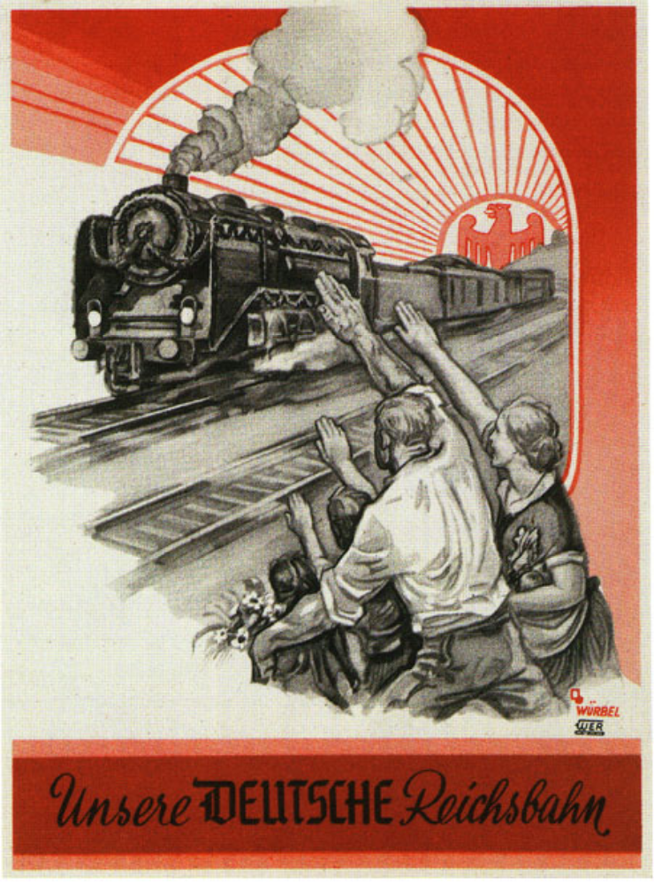
A poster promoting the German railway system from the 1930's.

Questions:

1. a. Explain briefly the reference “inherited customs” [Doc A] [2 marks]

b. What is the irony of Document C? [2 marks]

2. Compare and contrast the messages in Documents B and C. [6 marks]

3. With reference to their origin and purpose, assess the value and limitations for historians studying Documents A and D. [6 marks]

4. Using ALL the documents AND your own knowledge, explain how the Nazis sought to coordinate German society under the principles of National Socialism. [8 marks]

